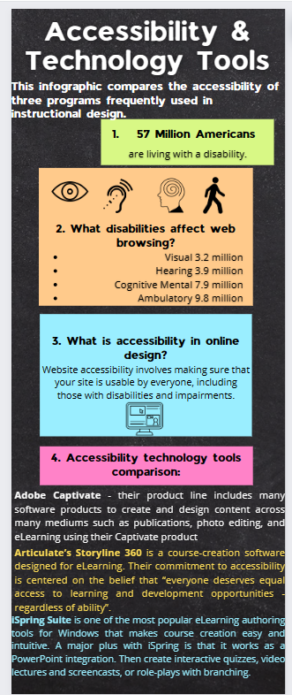

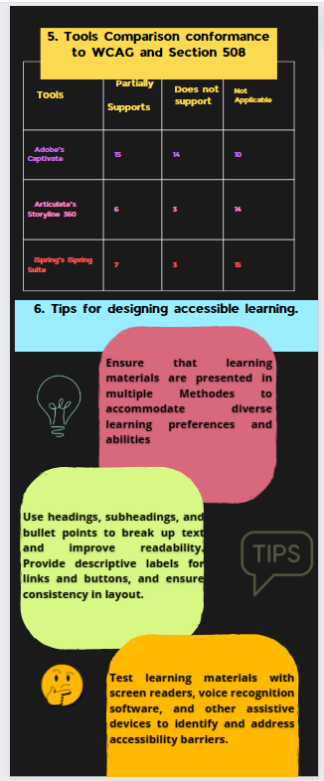

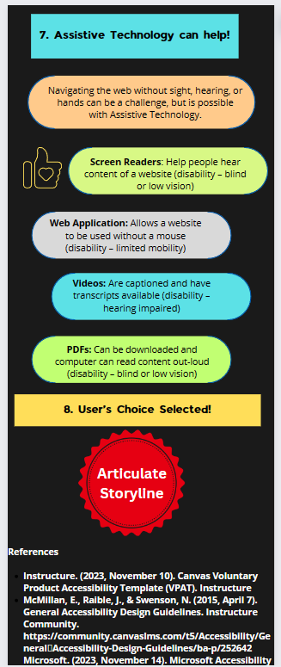

Here is my [Canva link:](https://www.canva.com/design/DAGAkofph5Q/UuYCQ9ChNN1_ZMr04whqZg/edit?utm_content=DAGAkofph5Q&utm_campaign=designshare&utm_medium=link2&utm_source=sharebutton)

<https://www.canva.com/design/DAGAkofph5Q/UuYCQ9ChNN1_ZMr04whqZg/edit?utm_content=DAGAkofph5Q&utm_campaign=designshare&utm_medium=link2&utm_source=sharebutton>

Infographic - Accessibility & Technology Tools

This infographic compares the accessibility of three program﻿s frequently used in instructional design.

# 57 Million Americans are living with a disability.

# What disabilities affect web browsing?

* Visual 3.2 million
* Hearing 3.9 million
* Cognitive Mental 7.9 million
* Ambulatory 9.8 million

# What is accessibility in online design?

Website accessibility involves making sure that your site is usable by everyone, including those with disabilities and impairments.

# Accessibility technology tools comparison:

* **Adobe Captivate** - Adobe’s creative product line includes many software products to create and design content across many mediums such as publications, photo editing, and eLearning using their Captivate product.
* **Articulate’s Storyline 360** is a course-creation software designed for eLearning. Their commitment to accessibility is centered on the belief that “everyone deserves equal access to learning and development opportunities - regardless of ability”.
* **iSpring Suite** is one of the most popular eLearning authoring tools for Windows that makes course creation easy and intuitive. A major plus with iSpring is that it works as a PowerPoint integration. Then create interactive quizzes, video lectures and screencasts, or role-plays with branching.

# Comparison of Captivate, Storyline, and iSpring Suite conformance to WCAG and Section 508

|  |  |  |  |
| --- | --- | --- | --- |
| Tools | Partially Supports | Does not support | Not Applicable |
| Adobe’s Captivate | 15 | 14 | 10 |
| Articulate’s Storyline 360 | 6 | 3 | 14 |
| iSpring’s iSpring Suite | 7 | 3 | 15 |

# Tips for designing accessible learning:

1. **Provide Multiple Modalities** - Ensure that learning materials are presented in multiple modalities to accommodate diverse learning preferences and abilities. Incorporate text, audio, video, and interactive elements to cater to various learning styles.
2. **Prioritize Clear Navigation and Organization -** Use headings, subheadings, and bullet points to break up text and improve readability. Provide descriptive labels for links and buttons, and ensure consistency in layout.
3. **Design for Compatibility with Assistive Technologies -** Test learning materials with screen readers, voice recognition software, and other assistive devices to identify and address accessibility barriers.

# Assistive Technology can help!

Navigating the web without sight, hearing, or hands can be a challenge, but is possible with Assistive Technology.

* Screen Readers: Help people hear content of a website (disability – blind or low vision)
* Web Application: Allows a website to be used without a mouse (disability – limited mobility)
* Videos: Are captioned and have transcripts available (disability – hearing impaired)
* PDFs: Can be downloaded and the computer can read content out loud (disability – blind or low vision)

1. Use’s Choice Selected!

Articulate Storyline has been selected as the most accessible technical tool for instructional designers.

## References

Adobe. (2020, January). [Adobe Accessibility Conformance Report](https://www.adobe.com/accessibility/compliance/adobe-captivate-prime-desktop-2019-acr.html). https://www.adobe.com/accessibility/compliance/adobe-captivate-prime-desktop-2019-acr.html

Articulate. (2024, March 14). [Storyline 360 Accessibility Conformance Report](https://www.articulate.com/about/accessibility/storyline-360-accessibility-conformance-report-vpat/). https://www.articulate.com/about/accessibility/storyline-360-accessibility-conformance-report-vpat/

iSpring. (2021, May 6). [Accessibility Conformance Report (iSpring Suite, iSpring Visuals)](https://www.ispringsolutions.com/articles/accessibility-mode-ispring-visuals). https://www.ispringsolutions.com/articles/accessibility-mode-ispring-visuals

Microsoft. (2022, January 13a). [Section 508 (Revised) Report](https://www.microsoft.com/en-us/accessibility/conformance-reports). https://www.microsoft.com/en-us/accessibility/conformance-reports